EXPERIMENT 6

1. create table bank (bankname VARCHAR(30),headoffice VARCHAR(30),branch VARCHAR(30), branchcode INT);
INSERT INTO BANK VALUES('sbi','CHANGANASSERRY','Thengana',123);
commit;

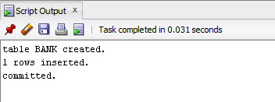

2. INSERT INTO BANK VALUES('SOUTH INDIAN BANK','Pala','Pathamuttom',234);
savepoint p1;

Insert into Bank values('IFDB','Chengannur','Tiruvalla',544);
savepoint p2;

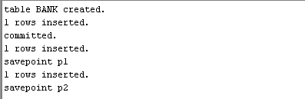

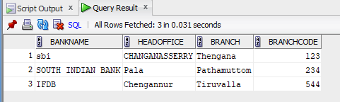

rollback to p1;

Select * from bank;

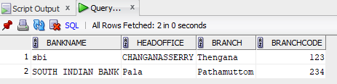

3. insert into bank values('Philip INC','Pala','kanjirapally',234);
savepoint p3;
insert into bank values('Siby inc','Malayil','Palakad',222);
SAVEPOINT P4;
insert into bank values('Boot house INC','Pala','kanjirapally',1134);
savepoint p3;
commit;
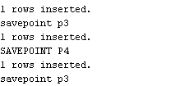

Select *from bank;

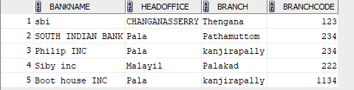

insert into bank values('Shaji INC','Puthupally','kanjirapally',1144);
savepoint p6;
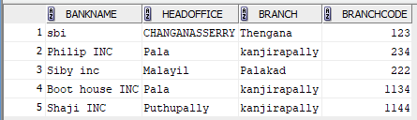
1.a rollback;
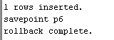

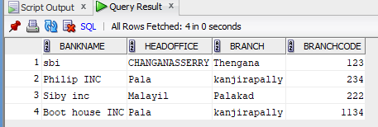

1.b insert into bank values('Alex INC','Puthupally','kanjirapally',1244);
savepoint p7;

insert into bank values('Raiwin INC','Monipally','kanjirapally',2344);
savepoint p8;

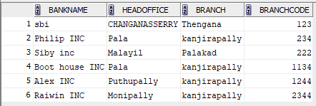

Rollback to p7;
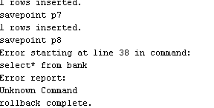
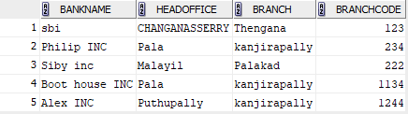

GRANT AND REVOKE

